Decreasing eye rolling using Operant conditioning
[Name removed per request]
Psych 101
Tues/PM
[Needs date of submission]

Abstract

This experiment examined operant conditioning to decrease eye rolling when at

the work place. The participant was a twenty-two year old female whom had continuous
-;:.:;
problems with rolling her eyes at her workplace. This behavior was modified using

punishment.

For a period of five working days the participant was trained to decrease eye

rolling with two snaps of two rubber bands placed on her right wrist. Every time she

rolled her eyes a snap occurred. This was done to make the participant realize that rolling
_

her eyes in the work place was wrong. Through operant conditioning subjects associate

behaviors with their consequences. From this experiment it is concluded that the subject

learned to stop rolling her eyes at the work place using punishment a tool in the operant

conditioning method.

Introduction

There are many different methods used for decreasing behaviors, such as eye

rolling. There is one particular method called punishment. Punishment is the removal of
_.
all pleasant stimulus or the application of an unpleasant stimulus, thereby towering the

probability of a response.

There are three ways in making punishment more effective. Those factors that

influence the effectiveness of punishment are: the timing, the intensity, and the

consistency. The timing of the punishment is very important. The punishment should

take place during the misbehavior as soon as possible after the misbehavior. The longer

the delay between the response and the punishment, the less effective the punishment is

at stopping the misbehavior. The intensity of the punishment is also an important factor

in stopping misbehavior. The more intense the punishment, the greater the suppression

of the misbehavior. The severity of the punishment should equal the severity of the

misbehavior. The last important factor in making punishment effective is the

consistency. You cannot punish the misbehavior one day and ignore it the next day. You

must be consistent in the application of the punishment. These three factors increase the

effectiveness of punishment.

In this experiment punishment, a tool in operant conditioning was used to

decrease eye rolling in the workplace. Operant conditioning is a type of learning in

which consequences of behavior are manipulated in order to increase or decrease that

behavior in the future. By modifying the behavior of eye rolling in the workplace the

subject had a more positive environment at work and decreased her chance of getting into

trouble with her boss.

Method

Participants

In this study one twenty-two year old female was used.


Apparatus

In this study two rubber bands around the participants right wrist were used.

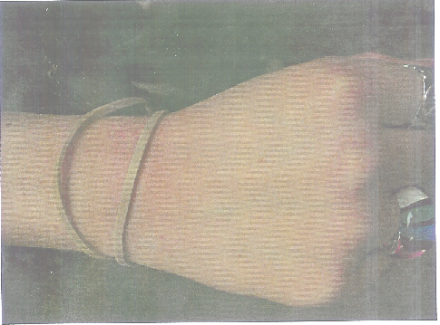

Procedure

The experiment encompassed five days during which the participant was at work.

The participant arrived at work and after clocking in placed two rubber bands around her

right wrist. Each time the participant rolled her eyes during the workday, she would give

herself two quick snaps of the two rubber bands placed on her right wrist.

The first day the participant only snapped herself three times because she was not

used to the procedure and would forget to snap the rubber bands. The second day the

participant snapped herself a total of fifteen times making her realize how often she did

roll her eyes in the workplace. She also realized how much pain the punishment

inflicted. On the third day she snapped herself seven times. On the fourth day she only

snapped herself three times. On day five no eye rolling or snapping occurred.

Results

The goal of the experiment was to decrease eye rolling in the workplace. This

was done by punishing the behavior with two snaps of two rubber bands on the right

wrist. This experiment proved to be successful. It encompassed a five-day workweek.

Once the participant was used to the procedure the number of misbehaviors and
_
punishments per day decreased and on day five no misbehaviors occurred.'



Discussion

During this study it was found that you could decrease eye rolling in the work

place by punishing the behavior. In order for the punishment to be effective it must take

place during the misbehavior, it must be intense, and it must be consistent. The

participant learned that by following those factors the punishment was more effective.

Once the participant had the procedure down, she associated rolling her eyes with the

snaps of the rubber bands. It made her more aware that rolling her eyes in the work place

was wrong. Thus the behavior stopped.

Reference

th .,
1 ) Wood, Wood and Boyd (2005), The W orId of Psychology, 5 edition Ally & Bacon

