Classical Conditioning Experiment:

Does age make a difference when creating conditioned responses?

By: [Name removed per student request]

[Notes:
Cover should have the date, class, and USDSU
There may be errors introduced by the scanning process
Instructor comments are in red type]
Abstract

For this classical conditioning experiment, I tested the unconditioned resp_mse of human

pulse rate rising after jumping up and down. I also caused a conditioned response by

tapping a ruler on a table just before their heart rate began to rise. The conditioned

response was that when the ruler was tapped, without them hopping on one foot, their

heart rate would rise. I tested their pulse rate five times and then also tested the

conditioned response twice:

1. Introduction

This experiment has the potential to let us know if we are able to cause a conditioned

response in humans and if age makes a difference in the response caused. By using the

ruler, that provides a conditioned response. This experiment is much like the one that

Ivan Pavlov once performed using dogs. Pavlov used a bell and food in order to train the
"

dog to salivate at the sound of the bell, without the food being present. Each time he

would ring the bell, he would also give the dog food, which caused the dog to salivate.

Eventually, the food was no longer needed for salivation. The experiment performed

related to Pavlov's in that both caused a conditioned stimulus. They were also both a

form of classical conditioning, which according to casaa-resources.com, plays an

important role in humans in learning emotional responses such as fears, attitudes, and

feeling towards particular objects. A person learns that there is an association between

two events.

2. Method

2.1 Participants

The total number of participants that took place in this experiment was two people. The

ages of these two people ranged greatly, them being eighteen and forty-three.

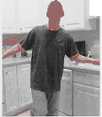
2.2 Apparatus

In this experiment, a ruler was hit on a table in order to create a conditioned stimulus. A

clock was used in order to time the pulse rate of the participants. After jumping up and

down, the participant needed to sit down on a chair to rest.

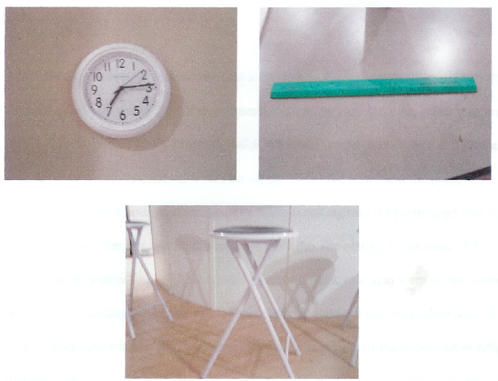
2.3 Procedure

First, the experimenter had the first participant sit down in a chair. The experimenter then

took the pulse rate of the participant for thirty seconds and multiplied it by two. This data

was recorded and called the resting pulse. Next, a ruler was hit on a table top five times,

and the participant was instantly instructed to stand up and jump on one foot for thirty

seconds. The participant then sat back down and the pulse rate was retaken and recorded.
This procedure was repeated 4 more times. After all data was recorded, the participant

rested for two minutes in order to get their pulse rate back down to the resting pulse rate.

Finally, the ruler was hit on the table top one last time and the pulse ofthe participant

was taken one last time. This entire procedure was then repeated for the second
. .

participant.

3. Results

After this experiment, it was proved that a conditioned response can occur if you do

something enough times. In this experiment, each pulse that was taken after jumping up

and down was higher than the resting pulse, which of course was expected. then, after

resting for two minutes, the ruler was hit on the table five times and the pulse went up.

This happened with both participants. The normal resting rate for participant one was

66/minute, but after just hitting the ruler on the table, the resting pulse went up to

74/minute the second time. This increase in resting pulse rate also went up for participant

two. The first resting pulse rate was 94/minute and when the rate was taken later, it got

up to 128/minute without jumping up and down. The results of the pulses taken after each

trial are graphed on the next page. The beginning resting period and the ending resting

periods differ greatly.

Graphed Results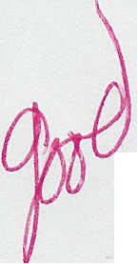

_Second | Age 43
Participant
Trial | Pulse
 | (per minute)
Resting Pulse | 94
 | it
Hop 1 | 124
Hop 2 | 116
Hop 3 | 116
Hop 4 | 120
HopS | 120
Sitting 1 | 128
Sitting 2 | 118
First | Age 18
Participant
Trial | Pulse
 | (per minute)
Resting Pulse | 66
Hop 1 | 80
Hop 2 | 92
Hop 3 | 88
Hop 4 | 92
HopS | 94
Sitting 1 | 70
Sitting 2 | 74

3.1 Age

In this experiment, we found that the older participants pulse rate rose more in the ending

resting time than the younger participants pulse rate did.

4. Discussion

This classical conditioning experiment showed how you can turn an unconditioned

response into a conditioned response. It showed that by making the heart rate go up by

jumping every time the ruler hit the table, you can then make your pulse rate increase just
by using the ruler. You will no long need to jump in order to get it to increase. This happens because the body gets used to that sound and relates it to the heart rate.

According to The World of Psychology, classical conditioning is a type of learning

through which an organism learns to associate one stimulus to another. So basically, this

experiment taught the participants to associate the noise, or in other words, the stimulus,

with their heart rate. A stimulus, also according to The World of Psychology, is any event

or object in the environment to which an organism responds.

This experiment proved how a certain reflex can become learned, or conditioned. It

proved that making a loud noise and relating it to a participant's heart rate will cause his

or her heart rate to rise each time they hear that noise. This is called the conditioned

response and it is very clear that this is what happened in this experiment. This

experiment just proved how the body can adapt to different things. By doing these things

over and over, your body eventually becomes used to them and reacts to them. Relating

your heart rate and the loud noise of the ruler hitting the table is just one example of how
you can show conditioned response.
Bibliography

Wood, S., Ellen Green/Wood, 'and Denise Boyd (2005). The World of Psychology. USA:

Pearson Education, Inc.

_'
(2005). The Conditioned Response. Retrieved AprilS, 2005, from

www.casaa-resources.net.

[Note: Format depends of document source – yours may differ.]

